**Assignment I**

**By Dedeepya Yarra (11594114)**

**3.1Ans.** The data set imported is as shown below it has 13 columns and 18254 examples

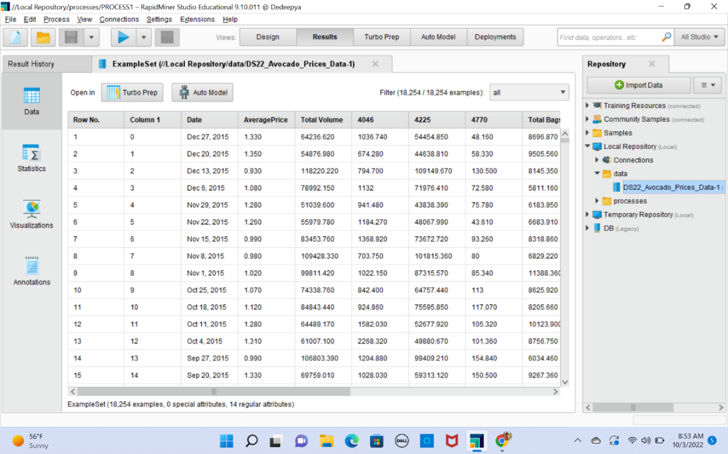

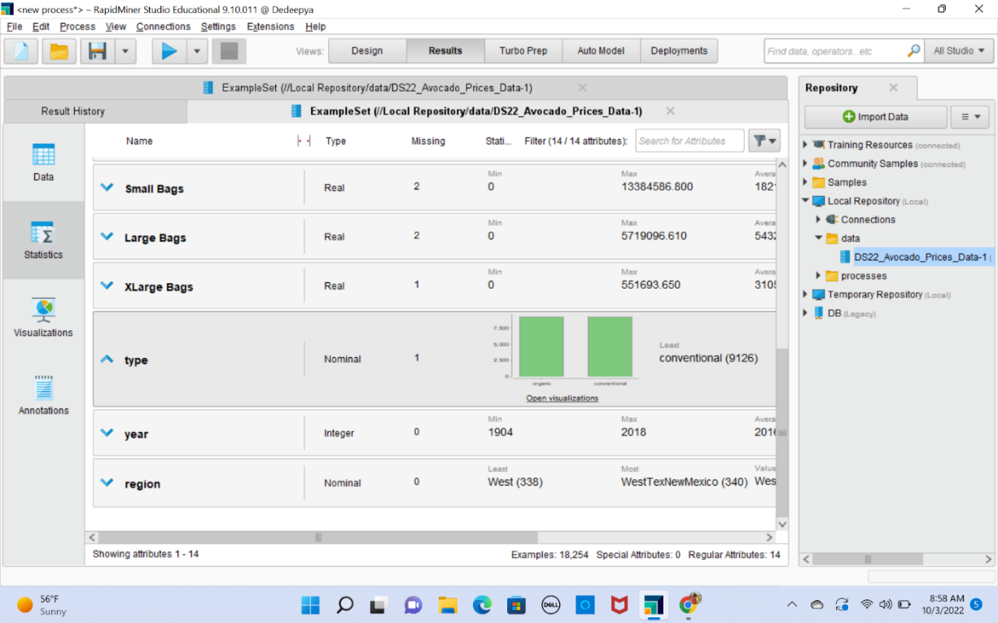Statistics of the column

By creating turbo model using raw data. If we have high precision and low recall which indicates there is low bias in data set and high variance. And if we have low precision and high recall which indicates there is high bias and low variance.

**3.2Ans.** There are duplicate values and missing values in given dataset, they can be removed as follows

Data will become corrupted and become larger due to redundancy. Using the remove duplicates operator, we must eliminate redundant data from the data collection.

Duplicate- From the below process Remove duplicate operator will remove duplicate values from data set

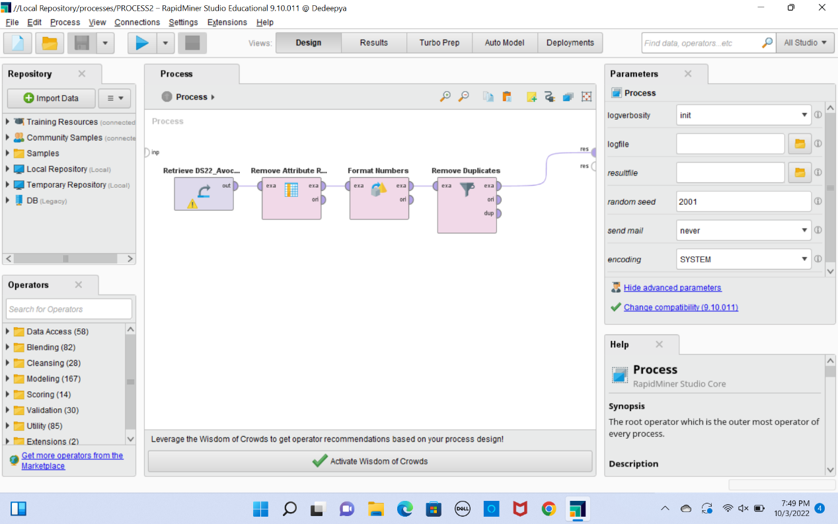

Result-

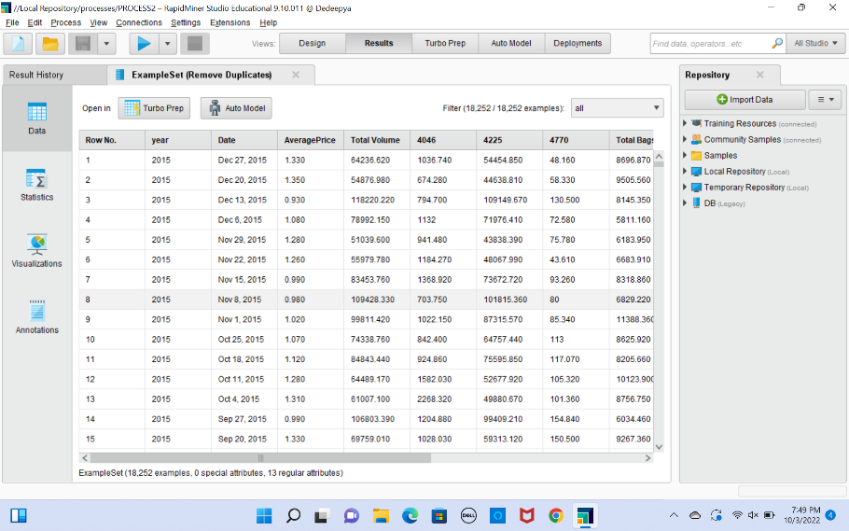

A study's statistical power can be lowered by missing data, which can also lead to skewed estimates and false findings. As a result, we must use the aggregate method to replace the missing data. Rapid Miner Studio's Replace Missing Values operator makes it easier for us to do this operation.

Below are the list of examples that has missing values in data set

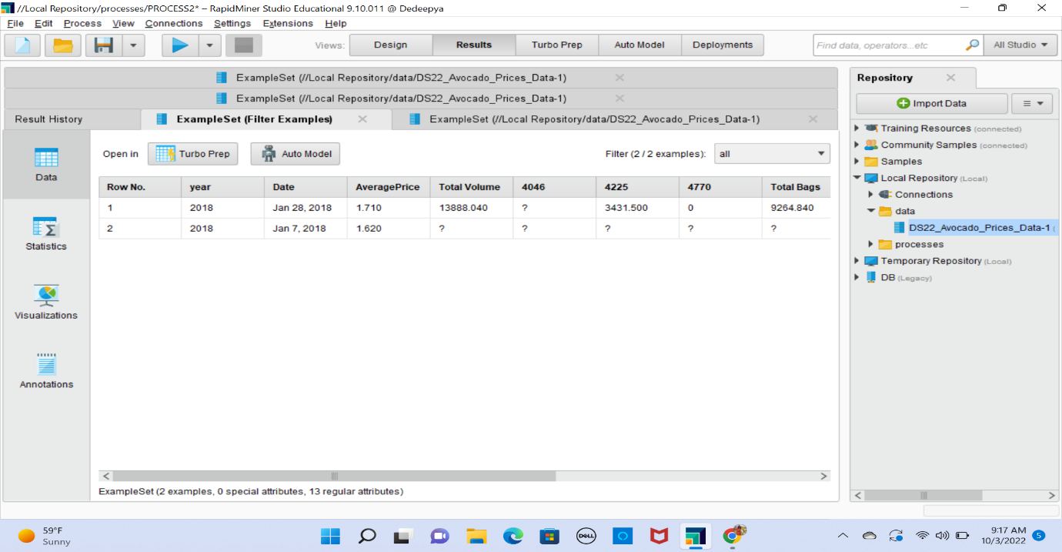

Below process will filter missing values based on the custom filter.

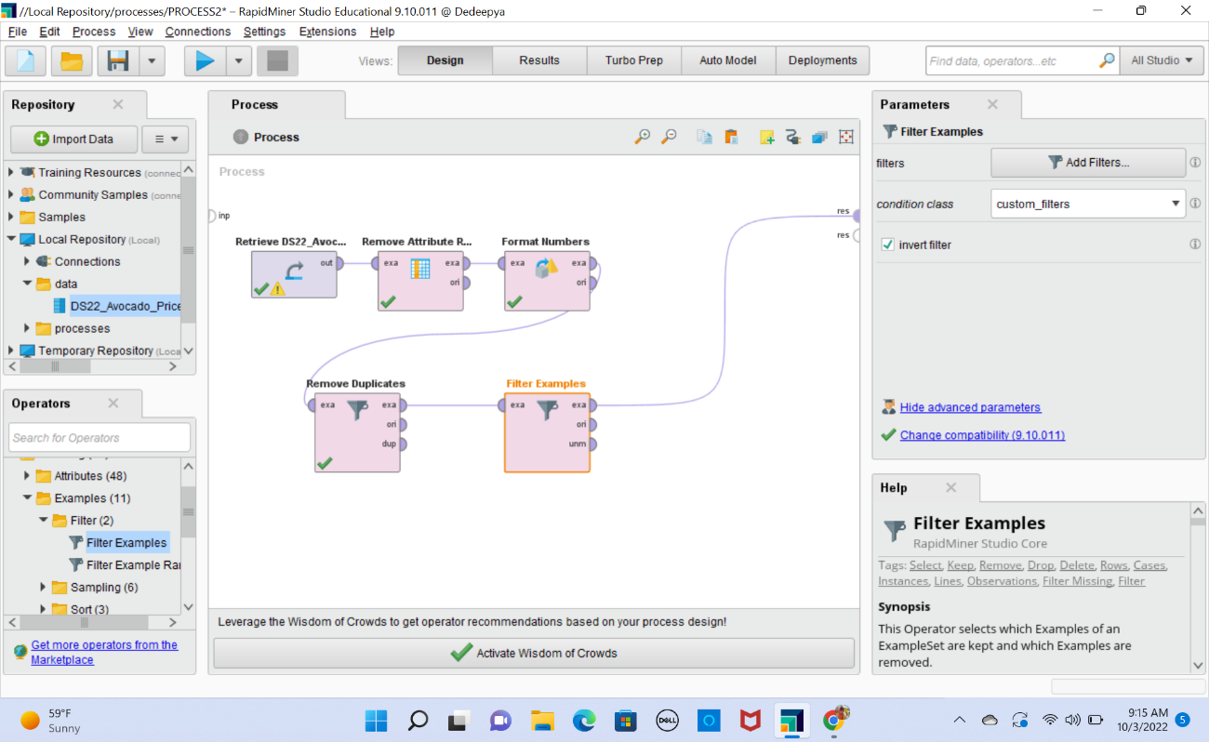

**3.3Ans** Applying the 10 times rule is the most typical technique to determine whether a data collection is sufficient. According to this guideline, the number of instances or input data should be 10 times more than the number of degrees of freedom in a model. Degrees of freedom often refer to variables in your data collection.

So, in our data set we have total 14 parameters, so we need at least 14*10=140 parameters for good model. We have 18254 records, so dataset is enough to train a model.

Image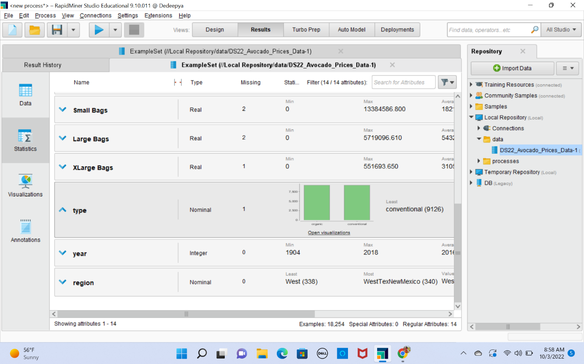

**4.1Ans** First column is removed with remove attribute range operator; we need to provide the range of indexes for the attributes to be removed. For the given data set when imported into rapid miner studio the datatype of year is number by using format numbers operator, we can convert it into ordinal

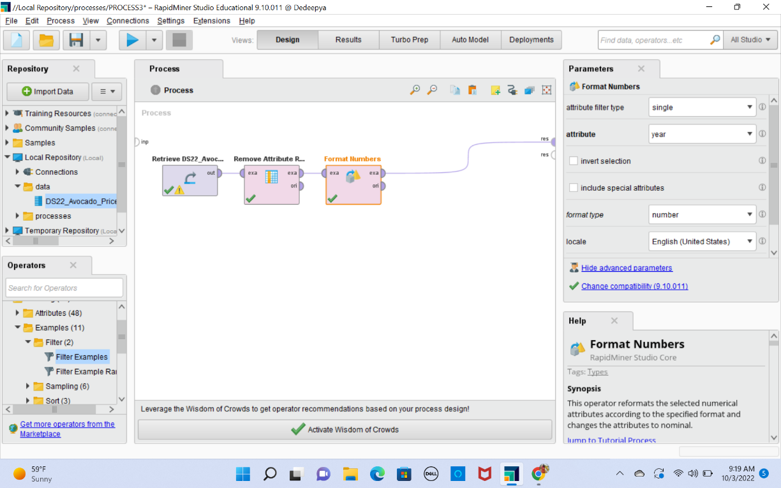

Result:

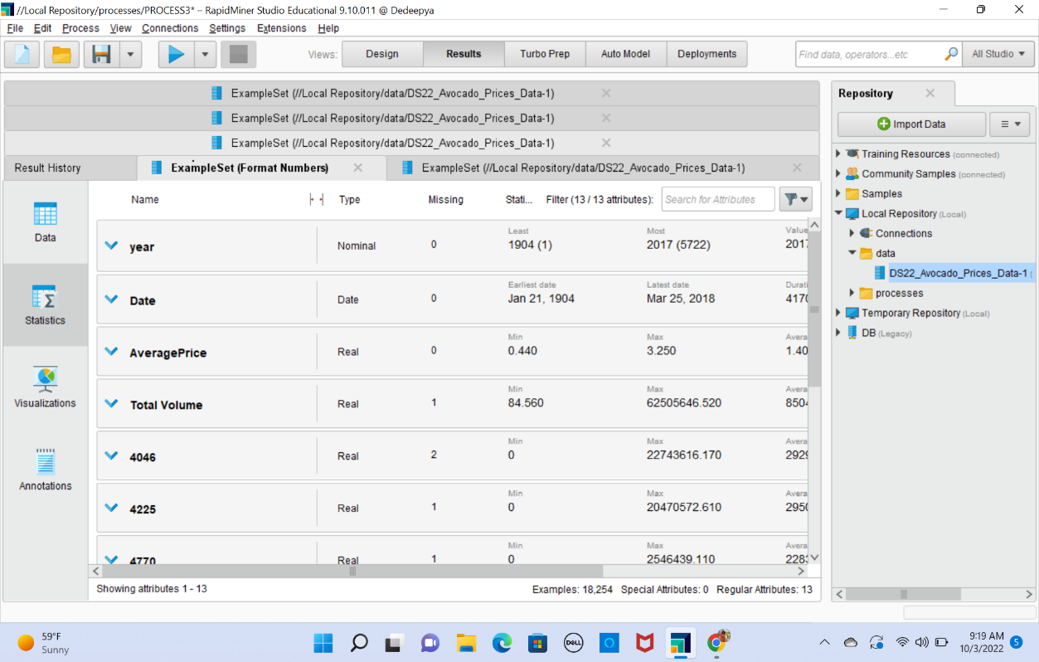

From the result we can see that data type of year changed to nominal

**4.2Ans** Data will become corrupted and become larger due to redundancy. The below-described Rapid Miner studio procedure is used to identify redundancy values. Using the remove duplicates operator, we must eliminate redundant data from the data collection.

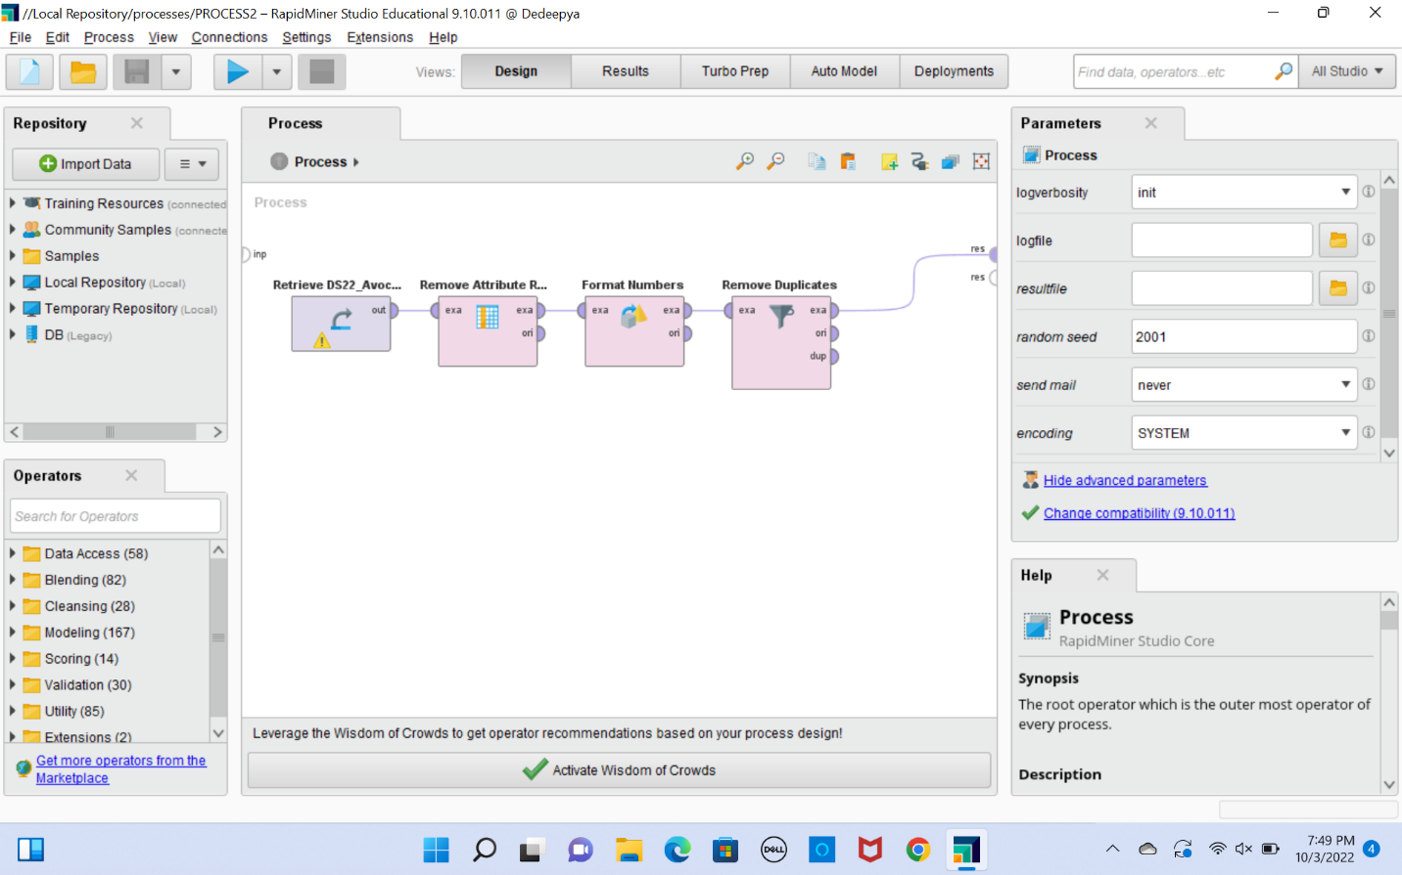

**4.3Ans** We can make use of generate aggregation operator to count number of missing values in each example.

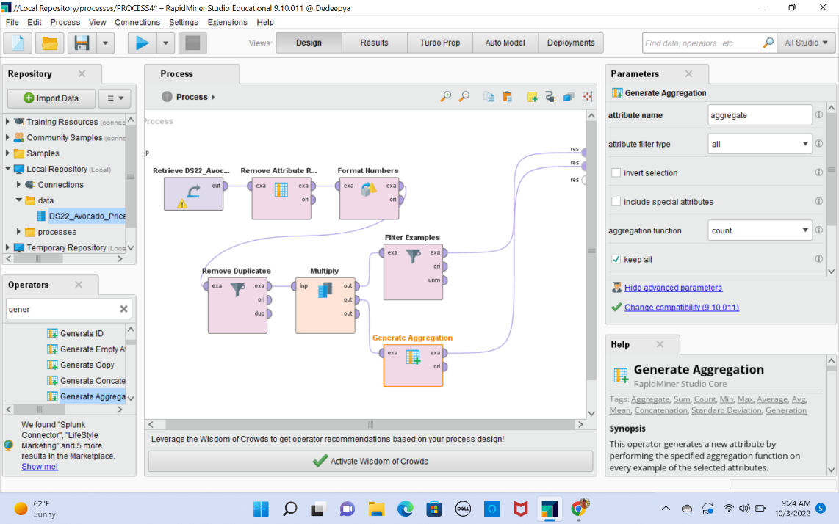

Result- we can see aggregate column in the table that counts no of values that are not missing in example

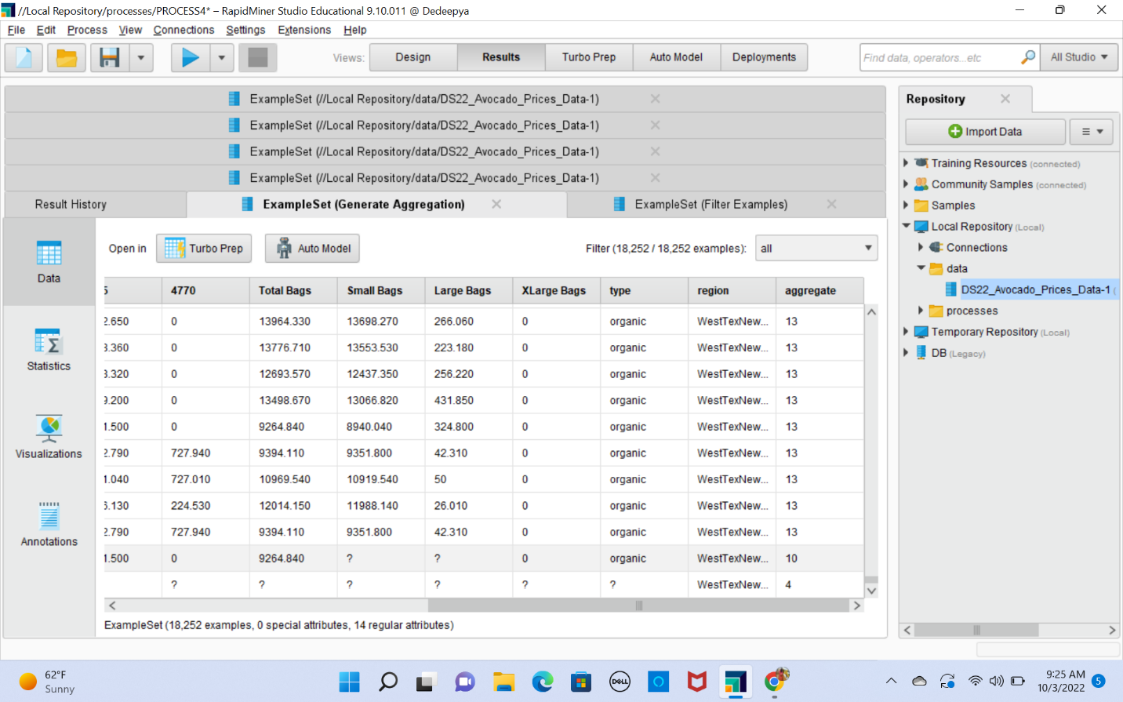

Next, we can use filter examples operator with custom filter which can identify missing values. With number of attributes less than 4.

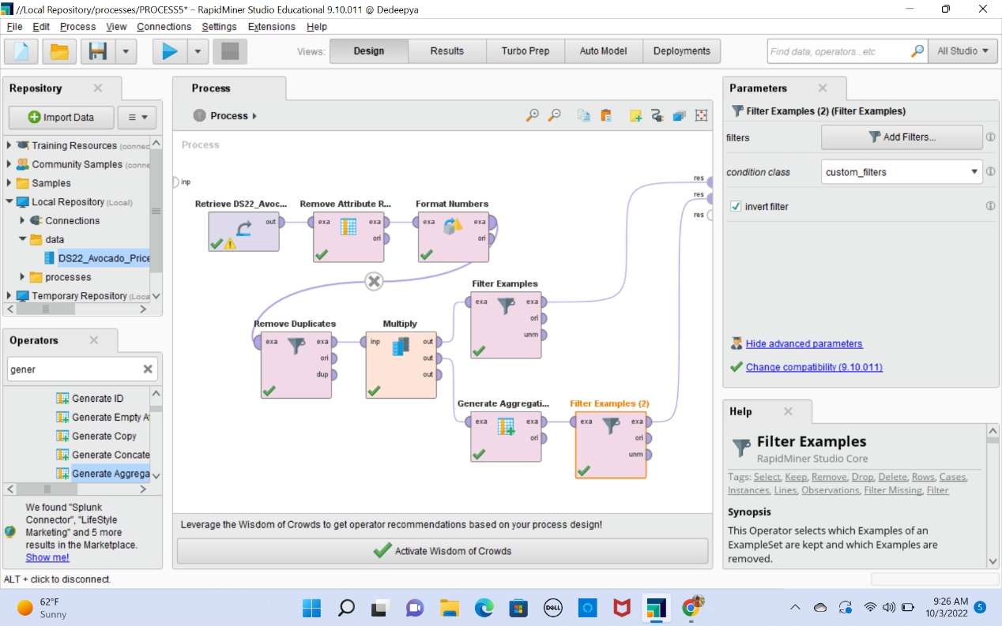

From the above process the examples which does not have values for at least 4 attribute are removed and result data set is as follows

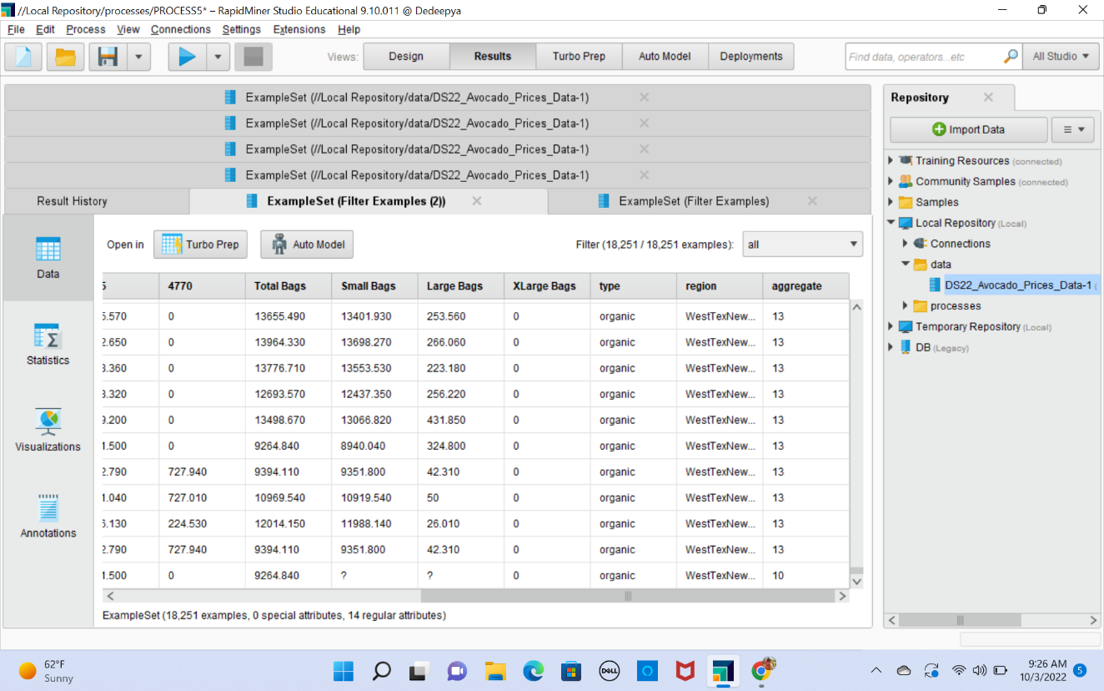

Now we can use aggregate operator to identify median of attributes which has missing values and missing values are replaced by corresponding column median

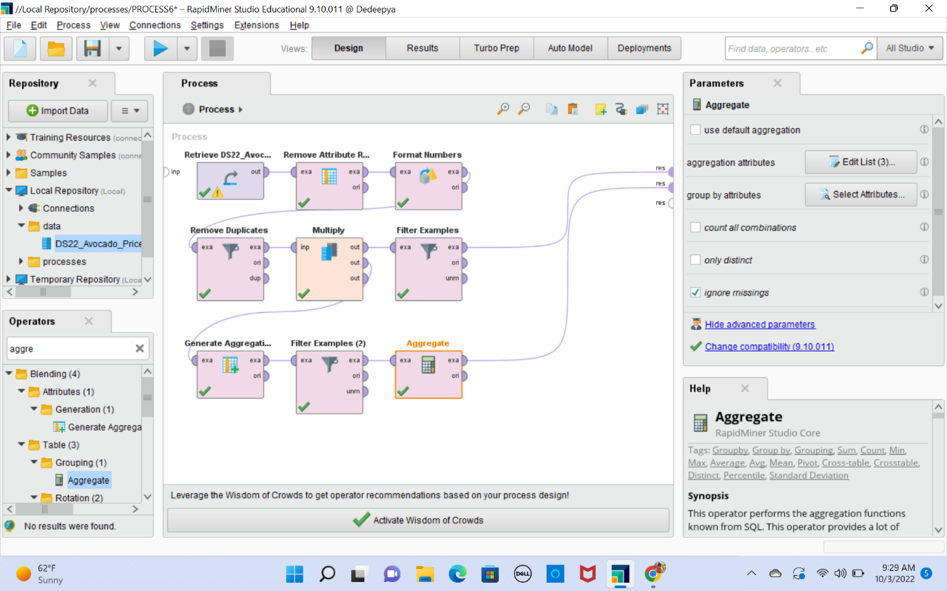

Result

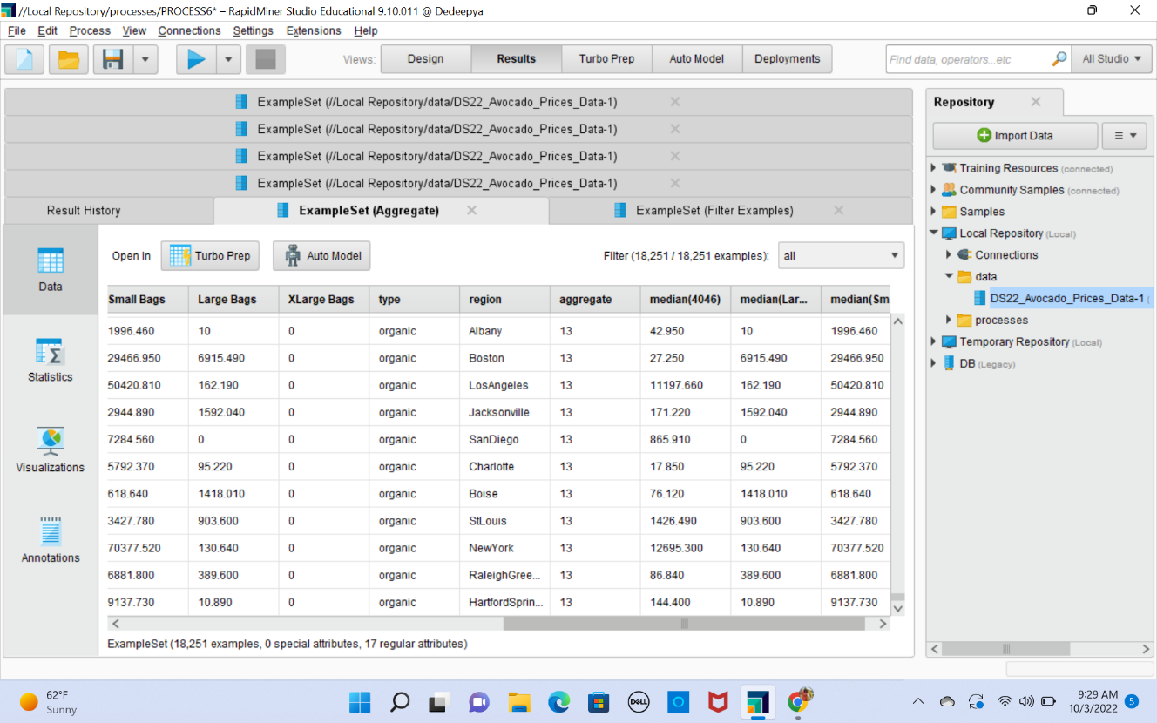

We have created some columns for calculating median. So, using remove attribute operator I have removed calculated median columns.

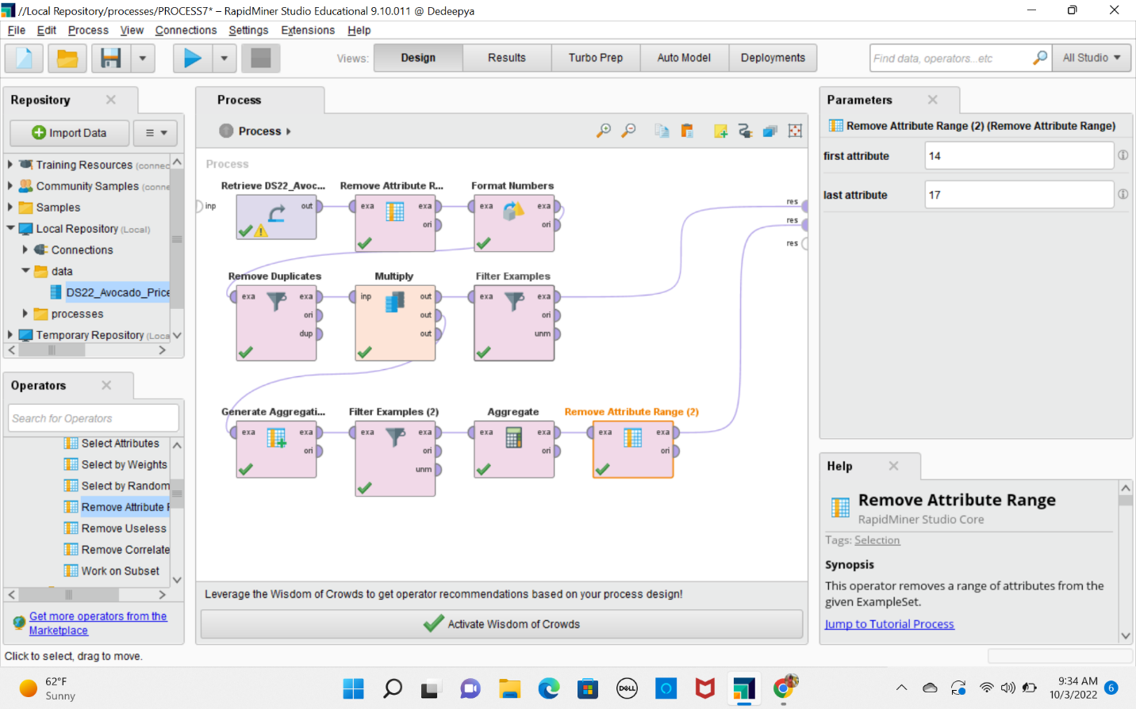

**4.4Ans** Correlation increases the model's accuracy. The level of confidence in the point estimate rises with more correlation. The strength of the association between two variables is gauged by the correlation coefficients. The most popular one in statistics is Pearson correlation. The degree and direction of a linear relationship between two variables is measured here.

With the help of correlation operator, we will get correlation between attributes.

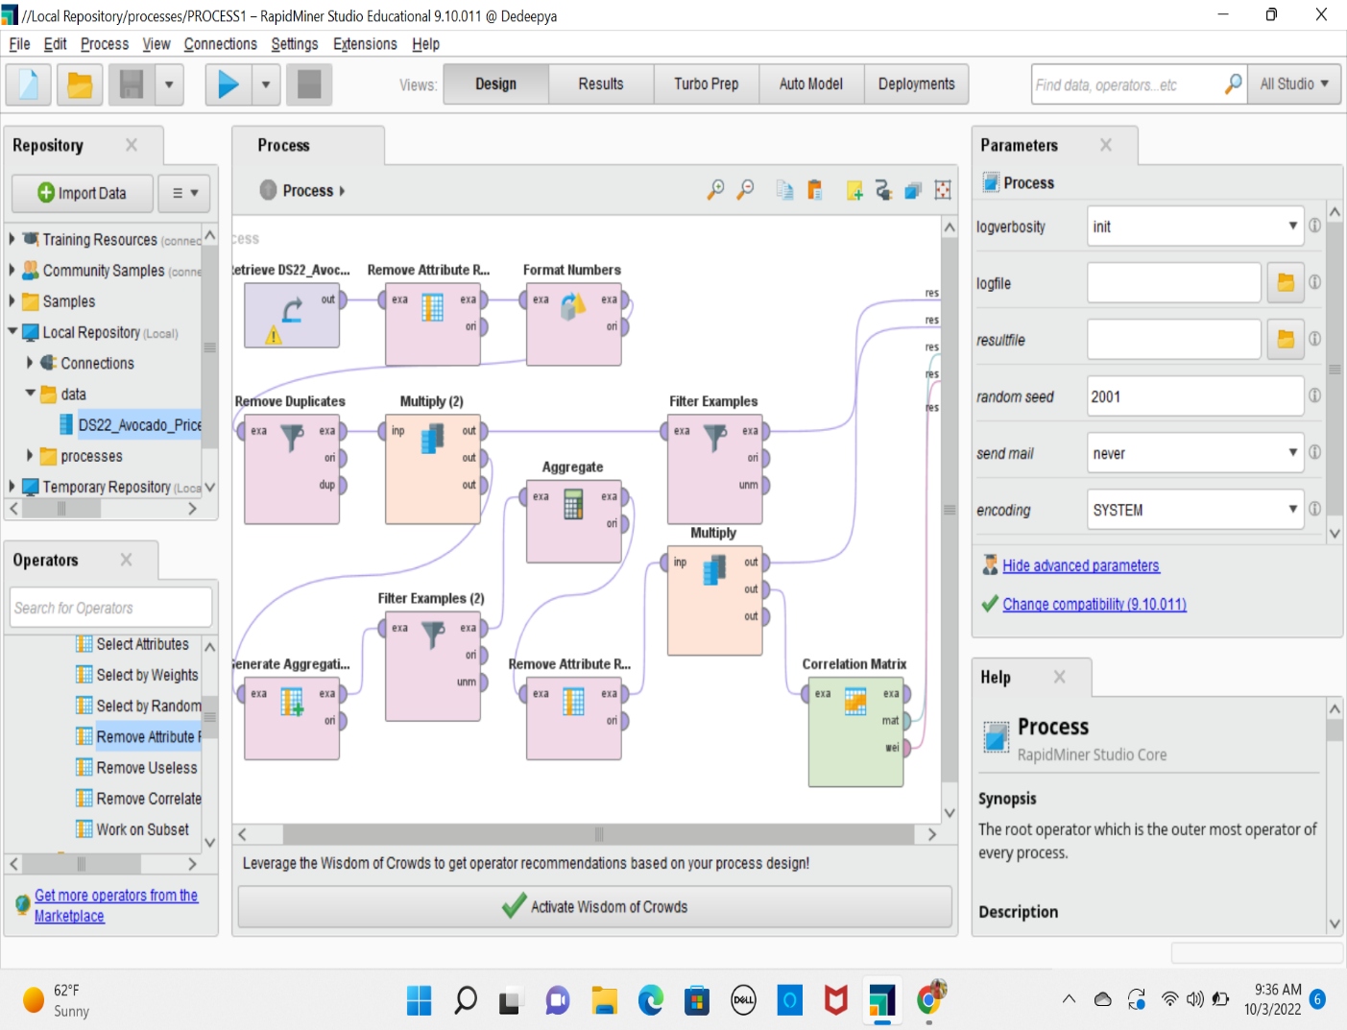

Resultant correlation matrix

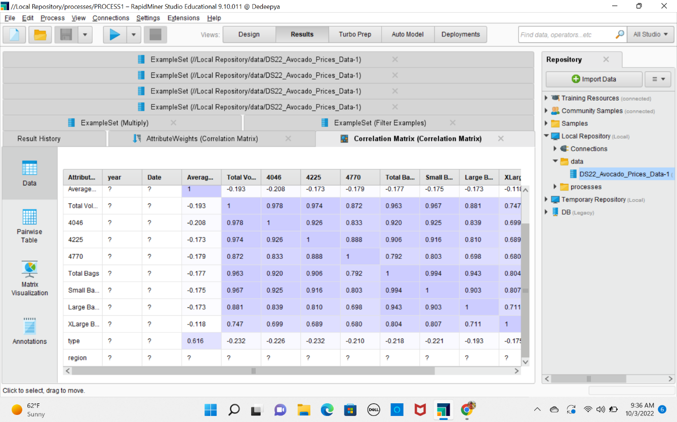

Weights from correlation matrix

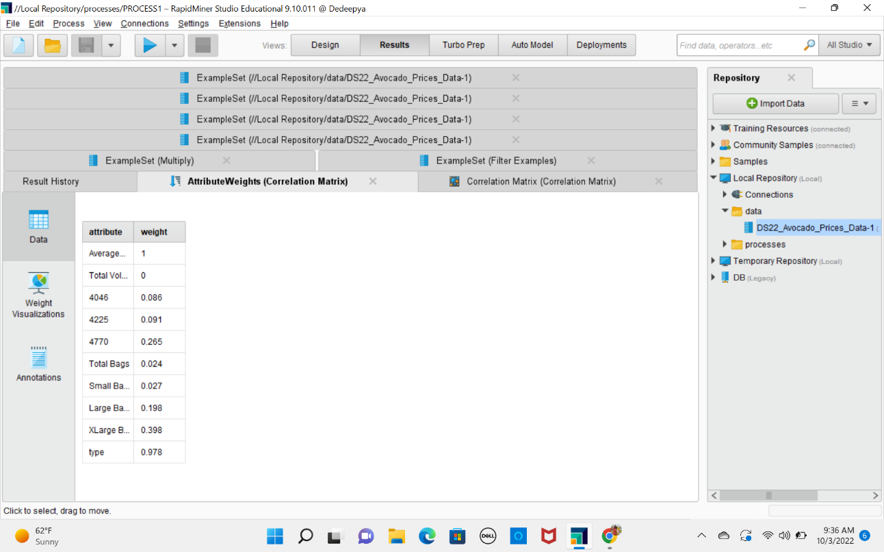

**5.1Ans** Below are screenshots that describes range, mean, median, distribution and count of unique value of each variable

Box Plot : It provides Min, MAX and ranges of all the attributes

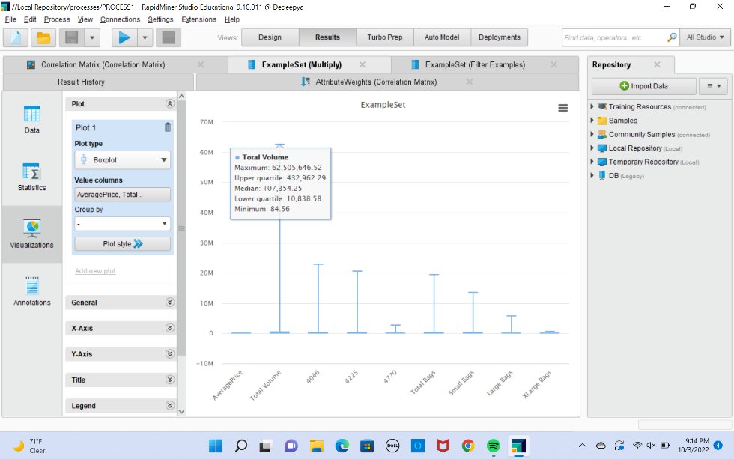

Attribute 1: year

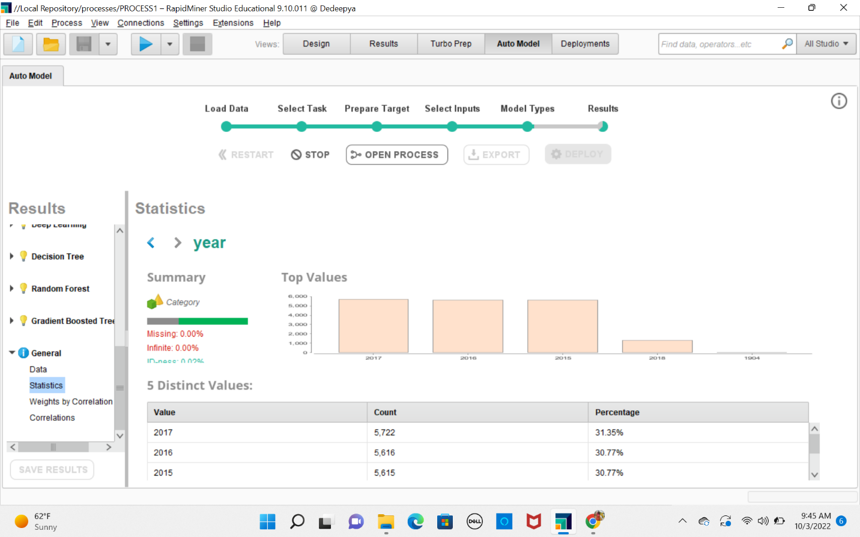

Attribute 2: Region

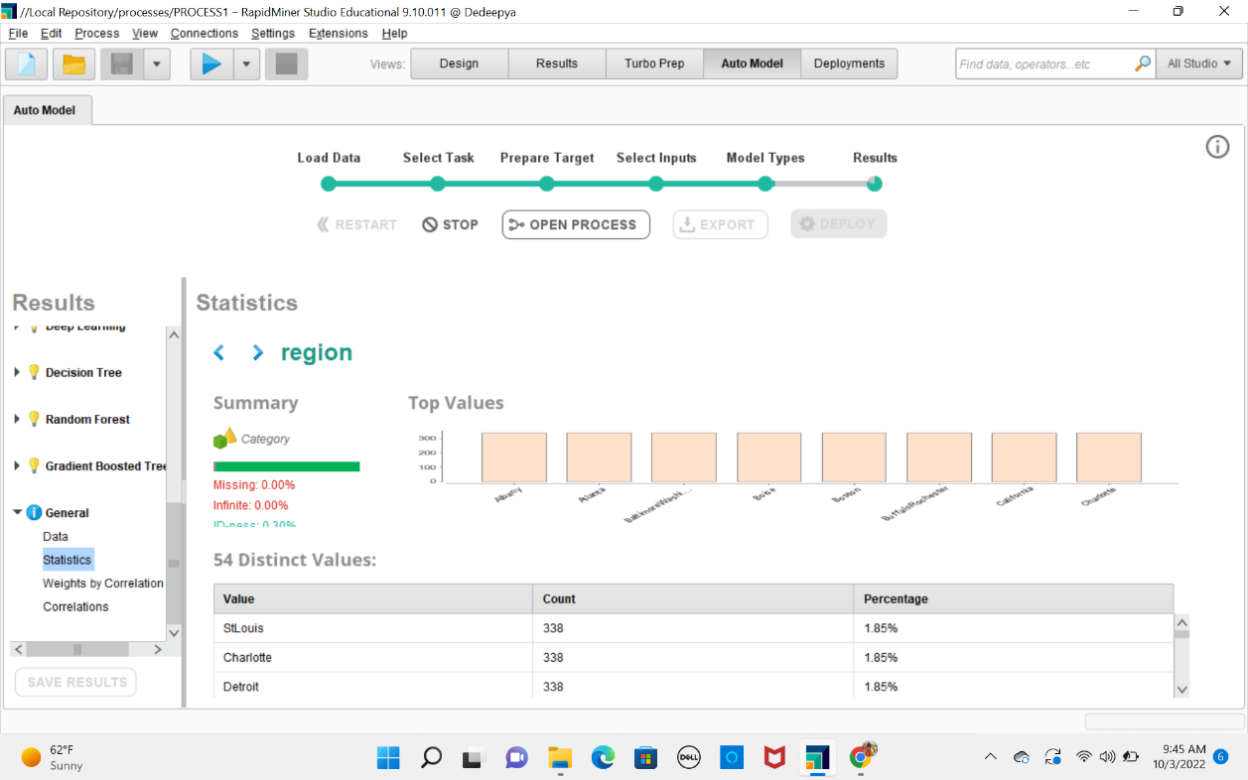

Attribute 3: Xlarge Bags

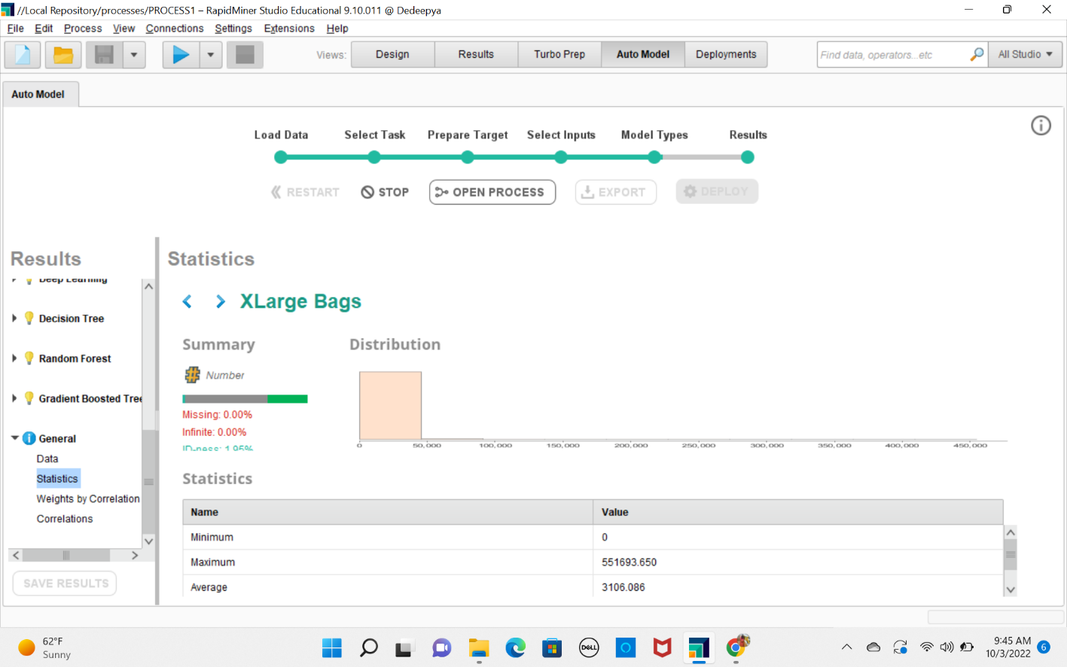

Attribute 4: Total Bags

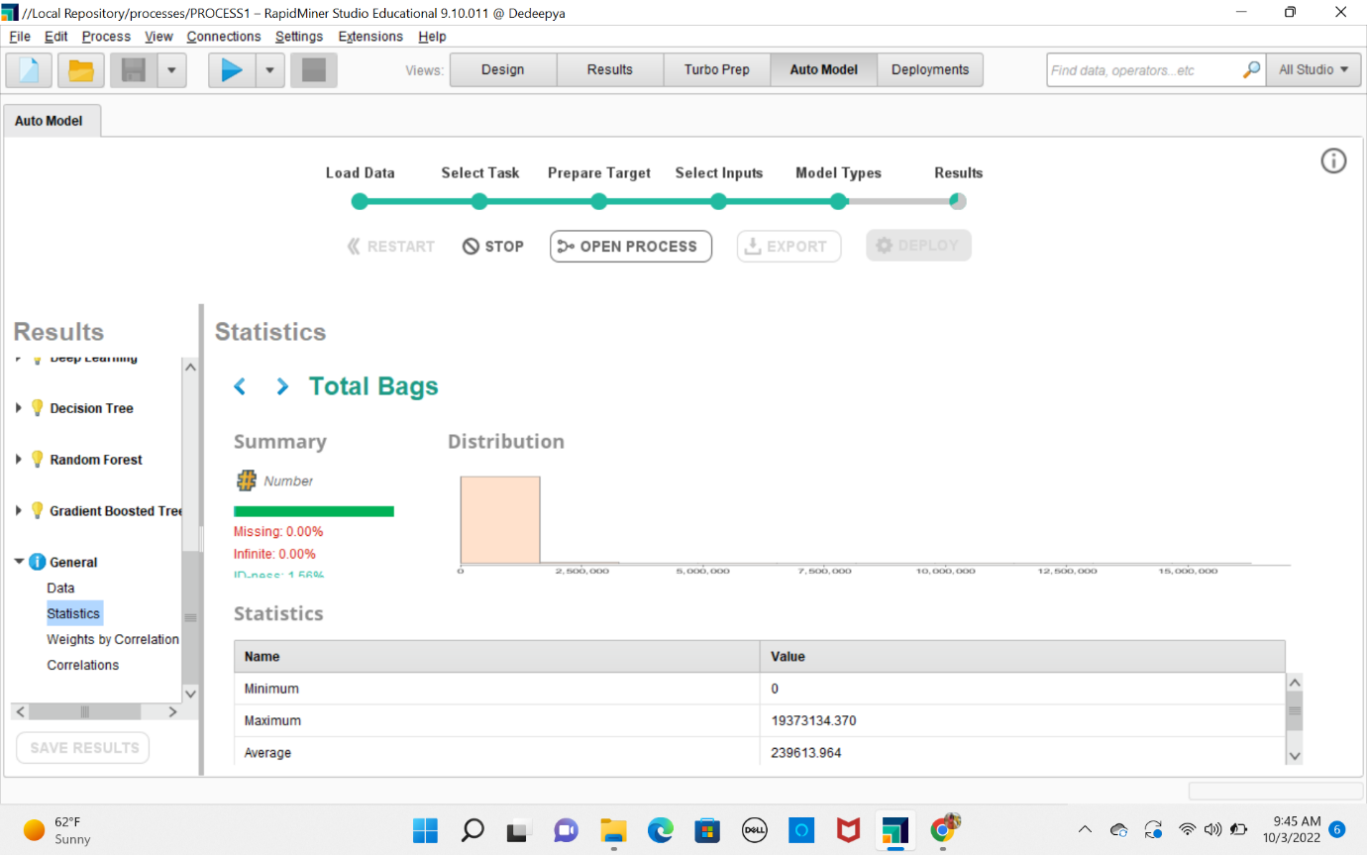

Attribute 5: Large Bags

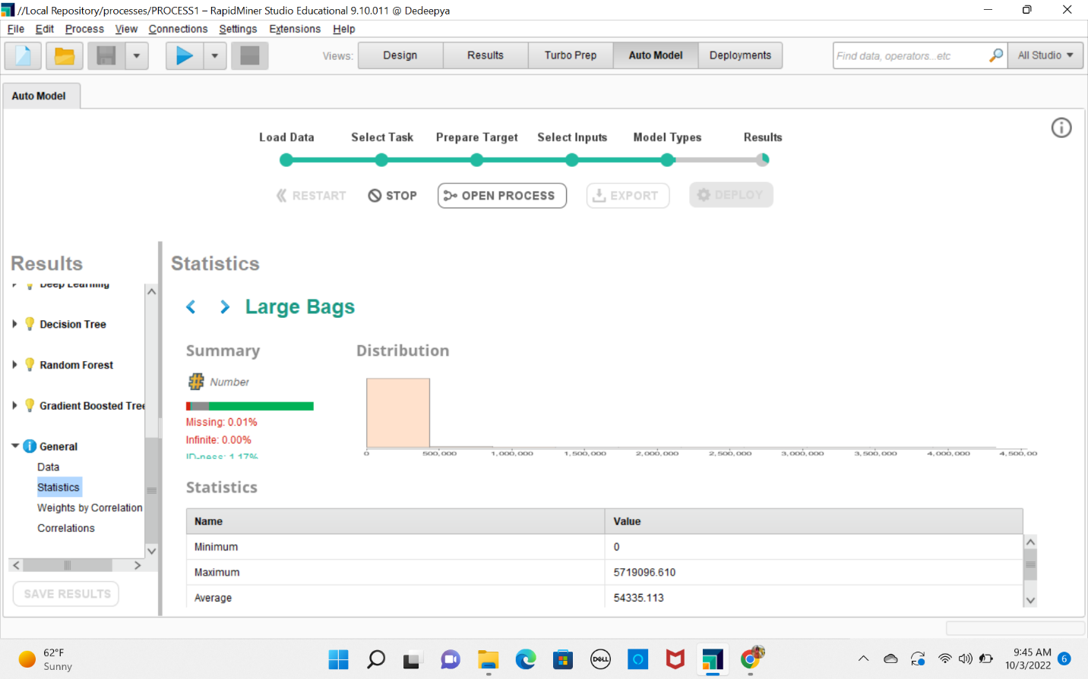

Attribute 6: Average Price

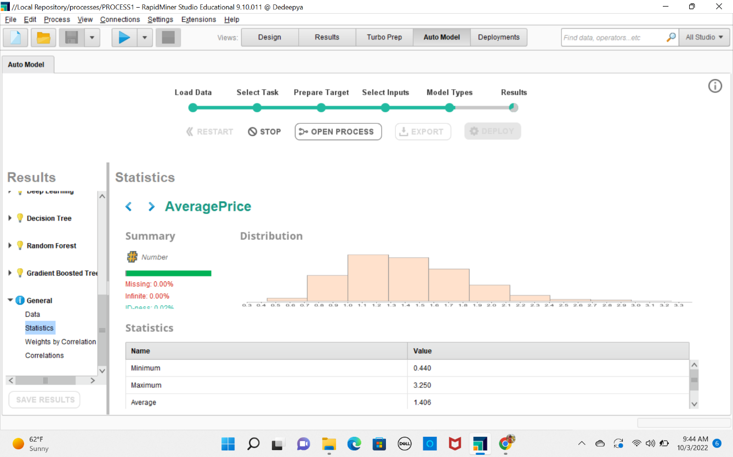

Attribute 7: Total Volume

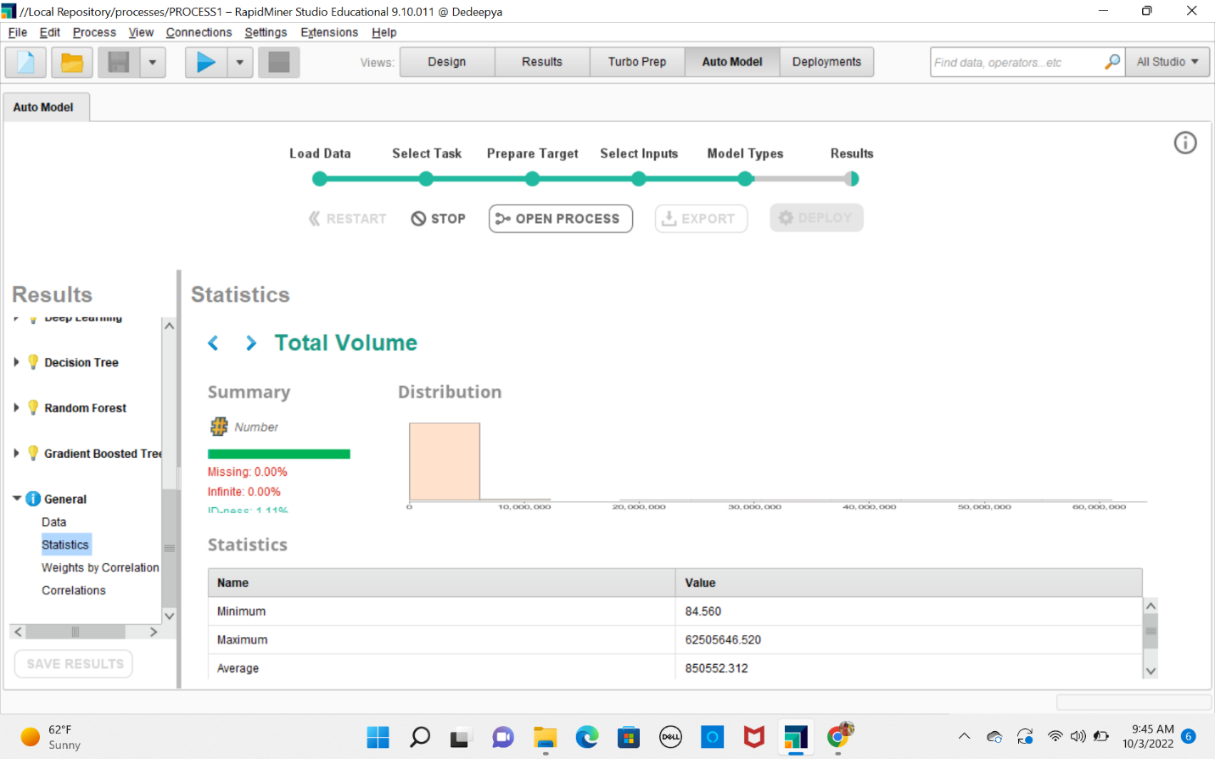

Attribute 8: small Bags

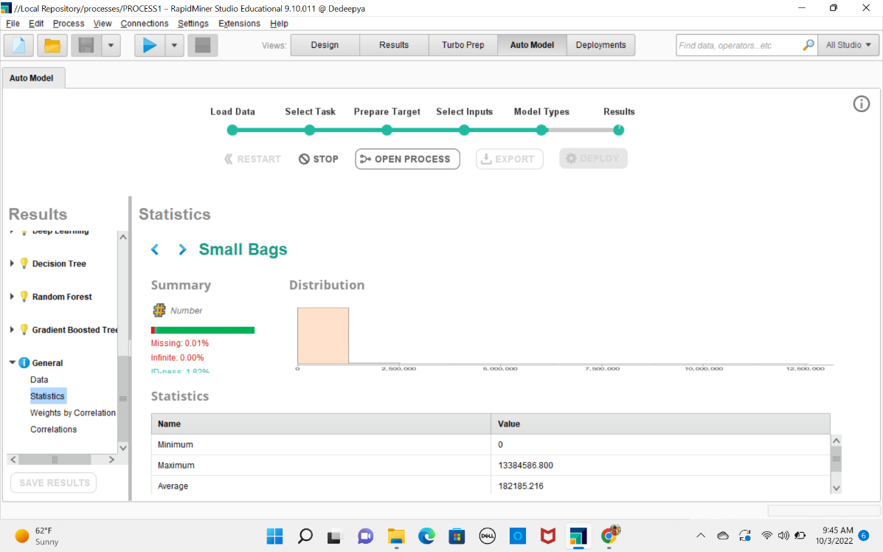

Attribute 9: 4770

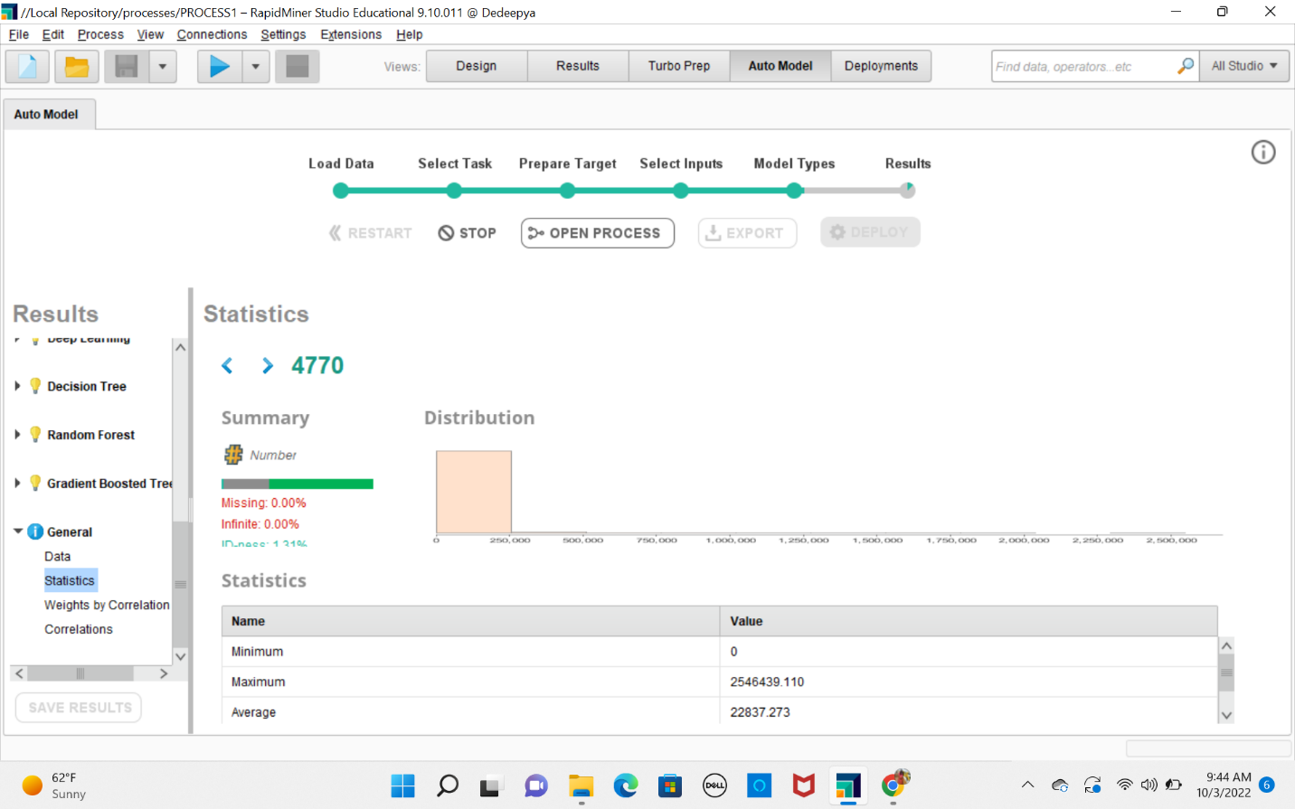

Attribute 10: 4225

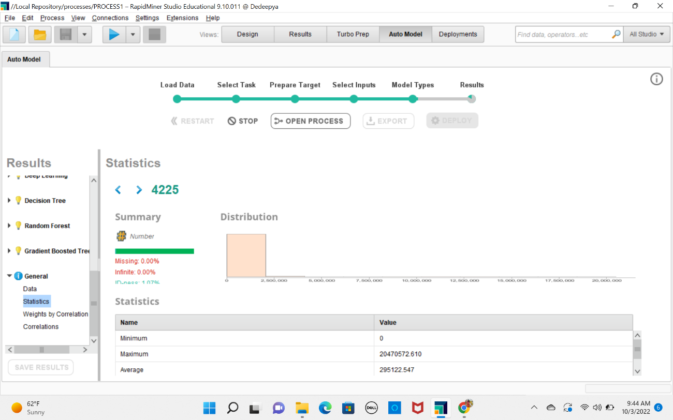

Attribute 11: 4225

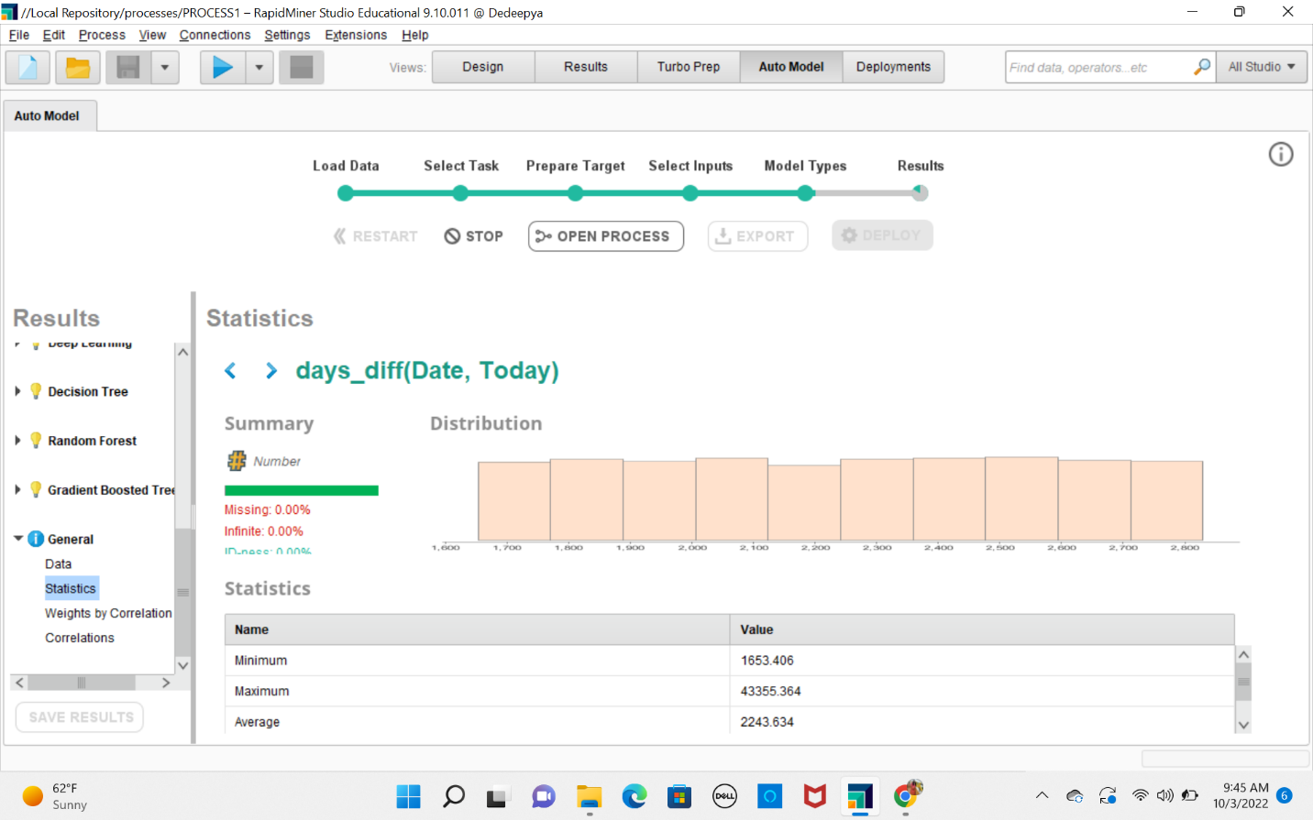

Attribute 12: 4046

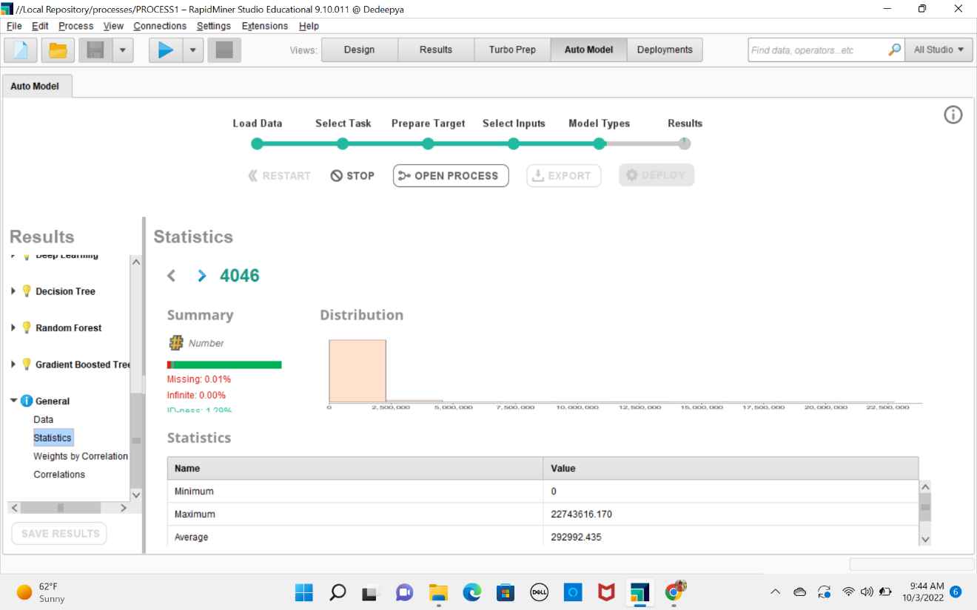

Attribute 13: Date

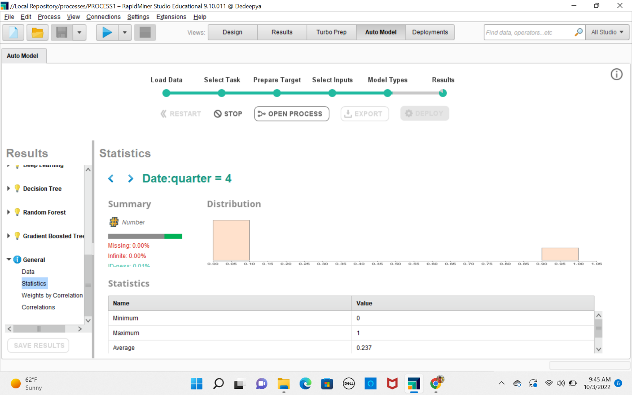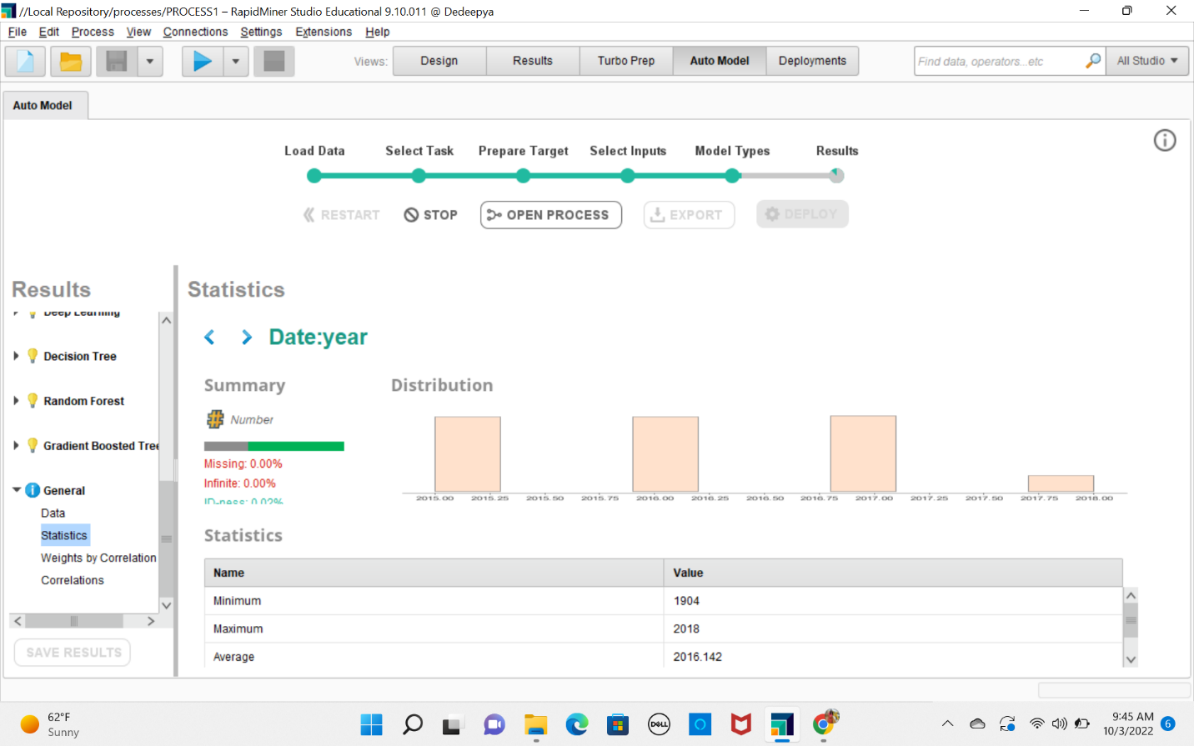

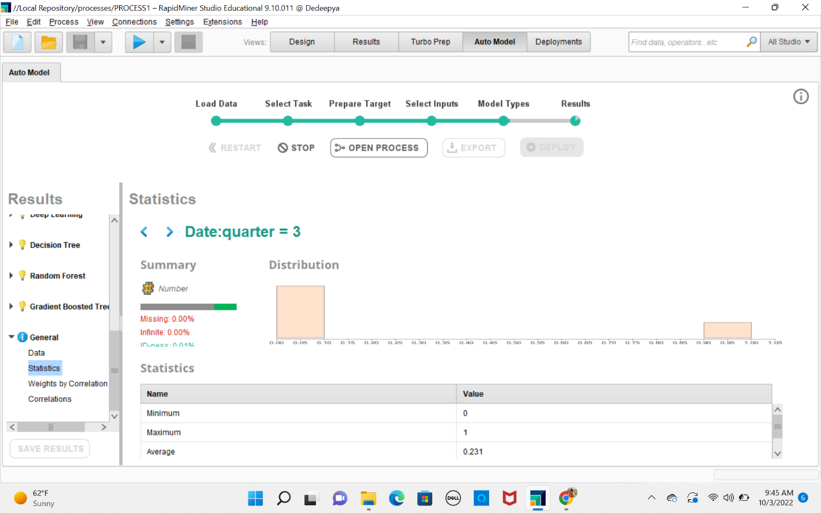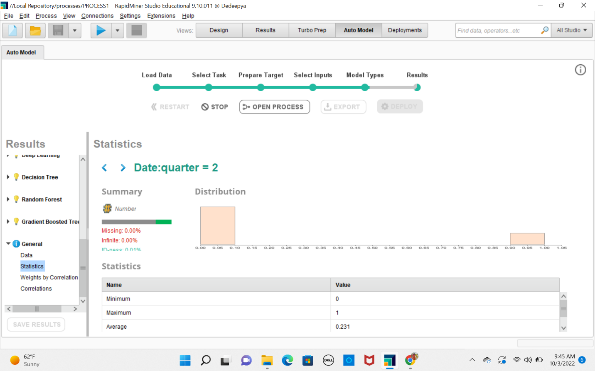

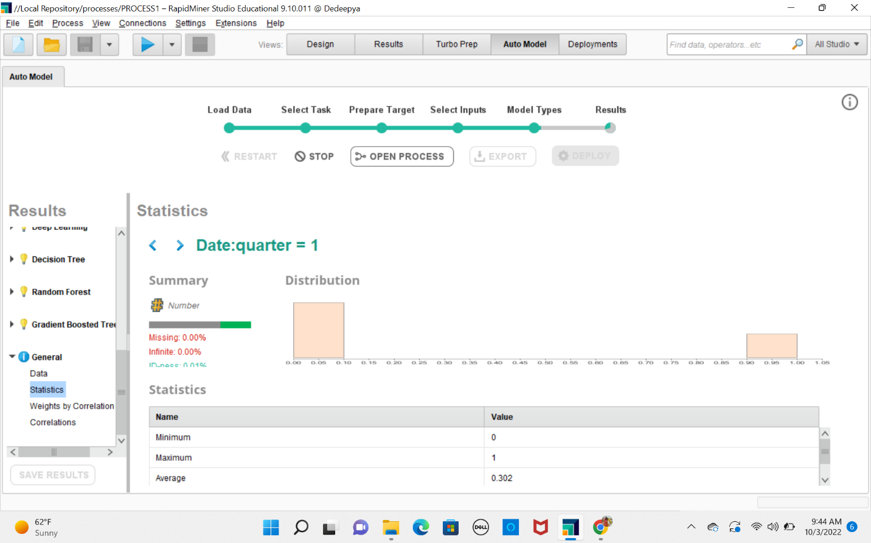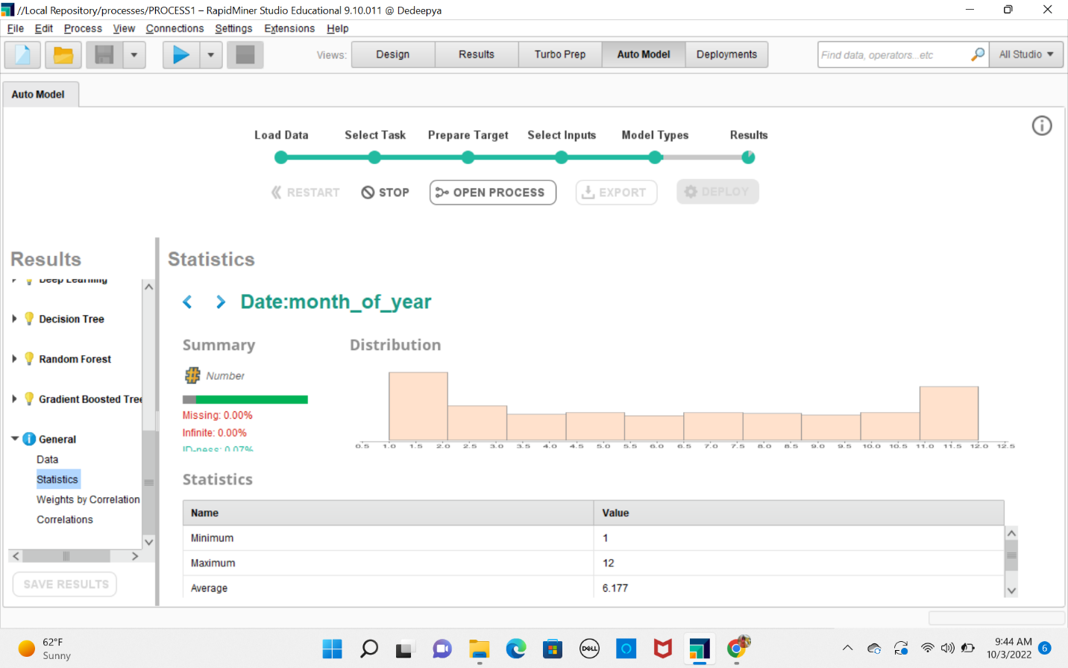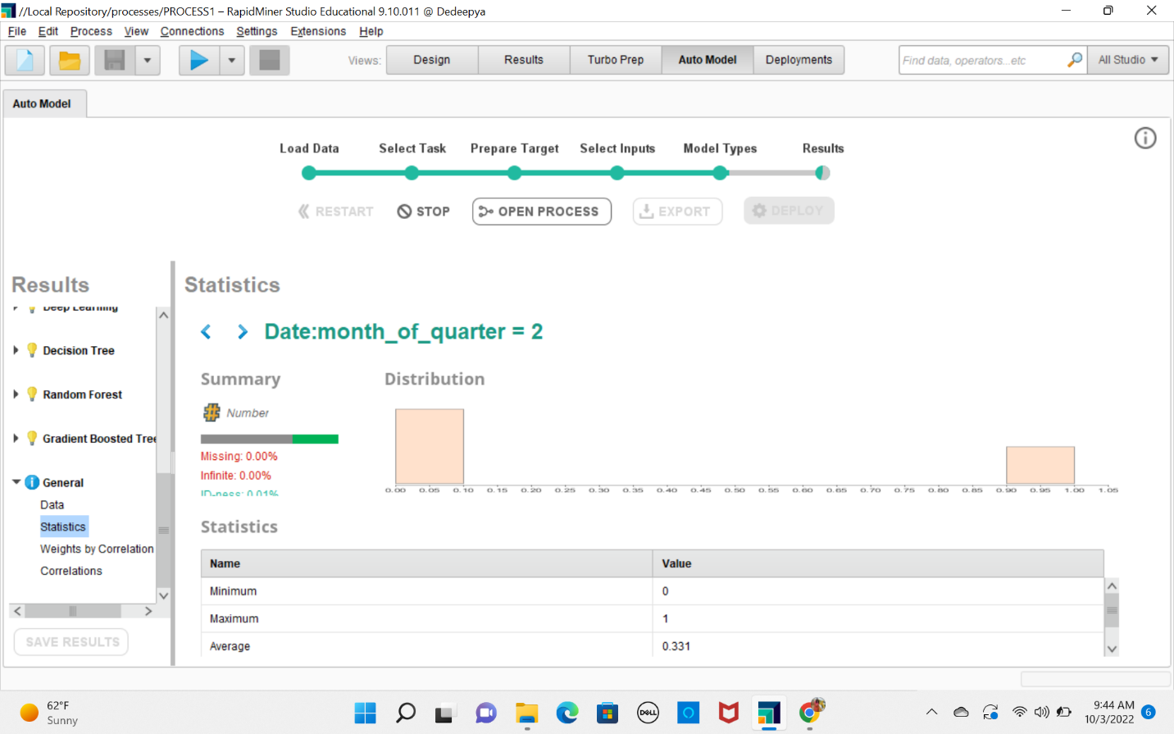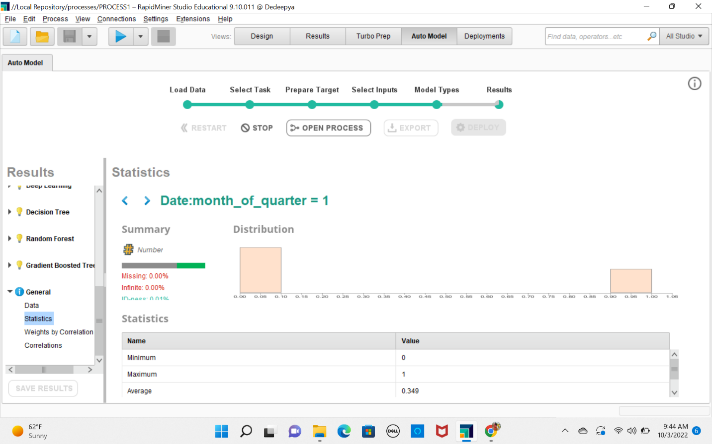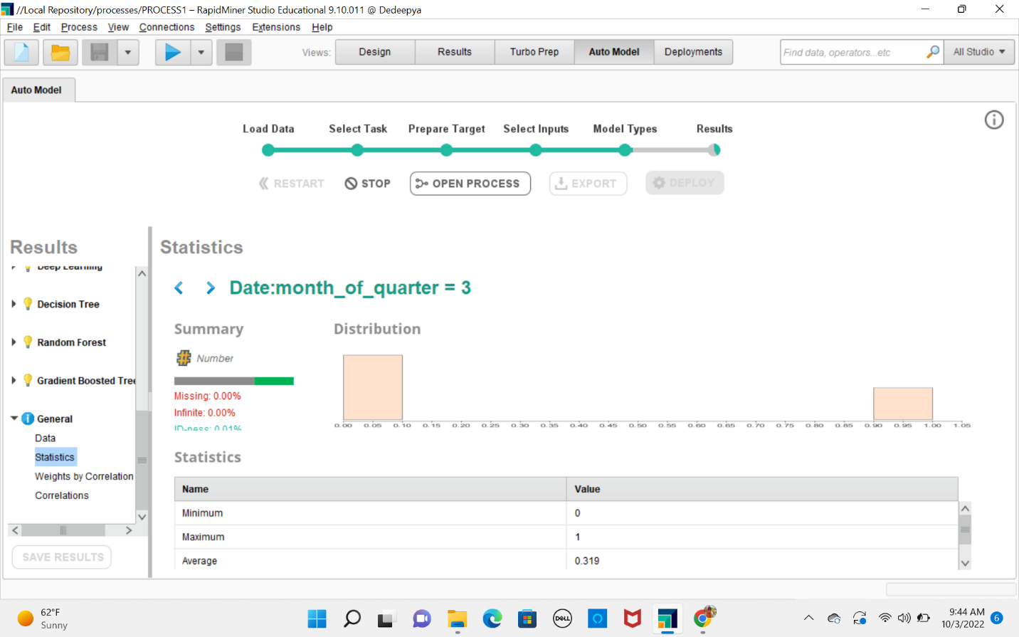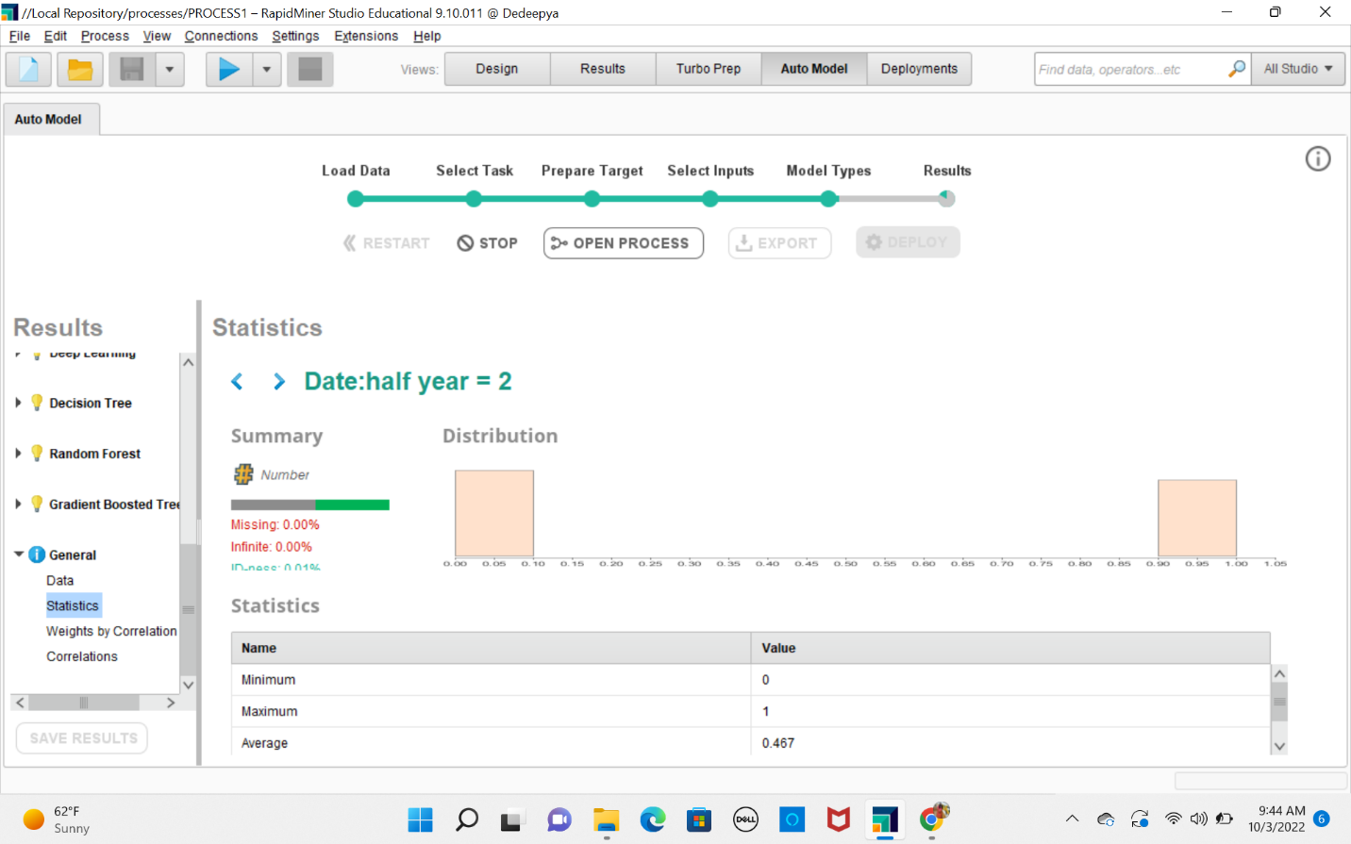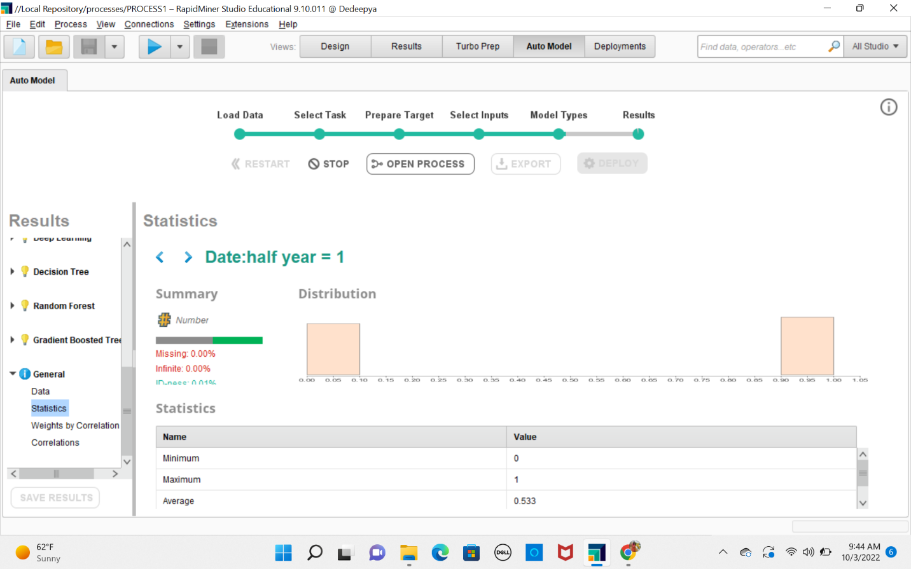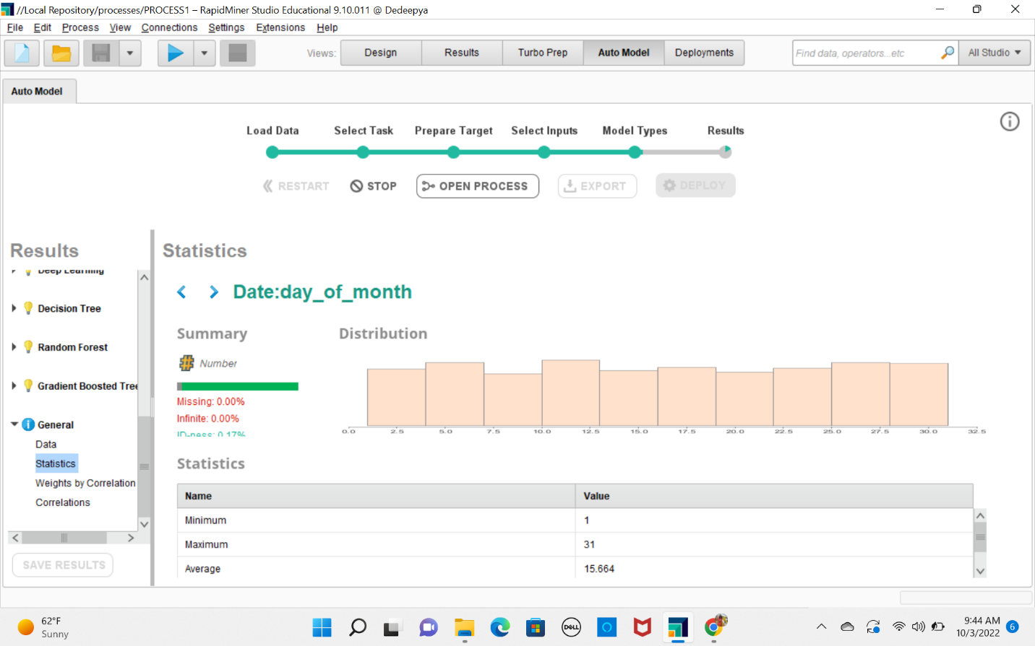

**5.2Ans** What is the earliest “Date” that the avocado price was recorded? Are there any avocado prices recorded from the earliest “Date” up to the year 2010?

Sorting result By date we can see that first date was Jan 21 1904.

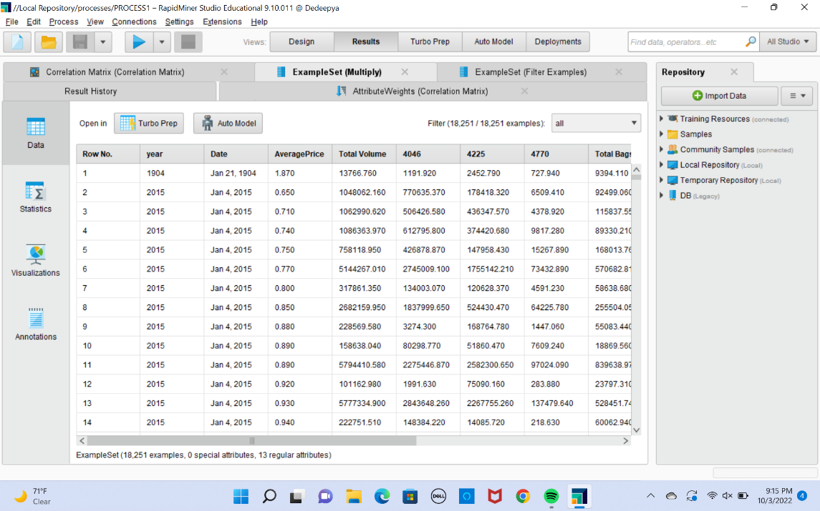

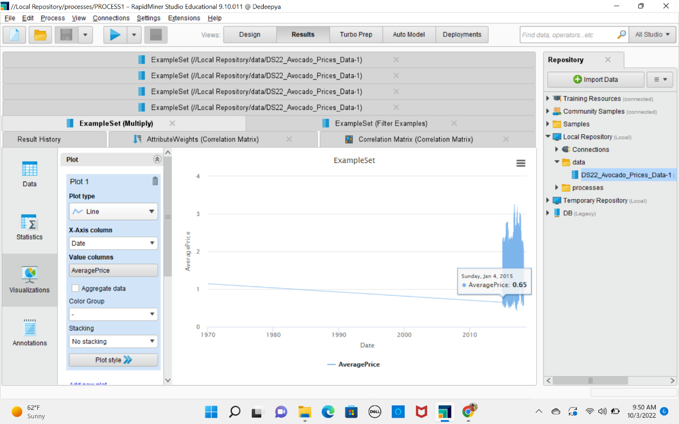

Earliest date was on Jan 21 1904. and there are no avocado prices recorded from 1904 to 2015 so we can we can delete it.

**5.3Ans**

From the scatter plot we can see that highest average price is at 3.25 and it region was at San Francisco. Scatter plot was created in rapid miner with x axis as regions and average prices as y axis

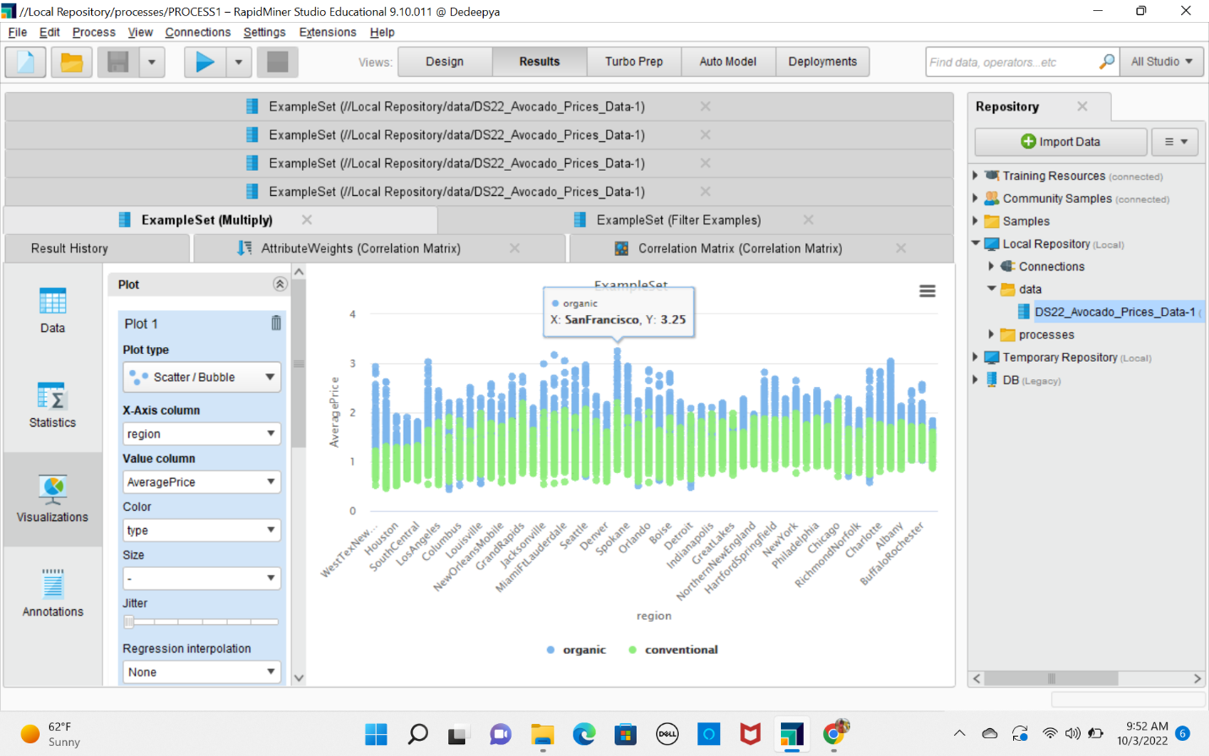

**5.4Ans**

From the scatter plot I can see that highest total volume as 62,505,646.52 and the region is TotalUS

